

**SUPERVISED BY : SIR DANIYAL GHANI**

**GROUP MEMBERS : MUJTABA ALI, M.HUSSAIN, SAIF ULLAH**

**Table of Contents**

Certificate of Completion 6

Acknowledgement 7

Project Synopsis 8

Functional Requirement 9

Problems Statement: 11

Proposed System 12

Hardware and Software Requirements 13

Website Features 14

Flow diagram 15

User Guide 16

• Homepage (landing Page) 16

• ABOUT US 17

• EXPERT TIPS 18

OUR STORES 19

• MAIN NAVIGATIONS: 20

➢ COOKWARE: 20

➢ REFRIGERATION: 21

➢ APPLIANCES: 21

➢ FOOD STORAGE: 22

COMPARE PRODUCTS: 23

SUB-DIVISIONS OF COOKWARE: 24

o COOKING POTS: 24

o COOKING PANS: 24

o COOKWARE SETS: 25

o HANDI’S 25

o KADAI’S(KARAHI) 26

o GRILL PANS 26

# 

# *Certificate of Completion*

This is to certify that **MUJTABA ALI M.HUSSAIN** and **SAIFULLAH**

have successfully completed their ACCP Semester I E-Project.

Submitted to: **Aptech Computer Education**

On

**March 19th, 2019**

# *Acknowledgement*

First of all we would like to thank Almighty Allah for giving us strength and ability to complete this project.

And then, we would like to express my special thanks of gratitude to our teacher **Sir Daniyal Ghani** who guided us on the project *Kitchen Appliances*, which also helped us in doing a lot of new learning and we came to know about so many new things we are really thankful to him.

We are highly thankful to **Sir Daniyal Ghani** for his guidance and constant supervision as well as for providing necessary information regarding the project & also for his support in completing the project.

Lastly, we would also like to thank our parents and friends who helped us a lot in finalizing this project within the limited time frame. We also express our sincere gratitude to E-Project team from Aptech Head Office, for their valuable guidance and support for the completion of this project. We earnestly hope that this project will provide all the necessary information required by the user to fulfill his/her inspiration. However, suggestion and Feedbacks for improvements will be thankfully welcomed & acknowledged*.*

# ***Project Synopsis***

Merciado Amusement park is now prime focus of the city and nation. It is made by Seth groups of companies. The development of this park took 5 years to get their desired finished product. It has became nation pride now. The area of theme park is about 45 acre land. The Management has put all the efforts to keep the attractions operational. The merciado management wants you to develop the website of the park which should include describing all the attraction of the park and also allow the user to book the ticket online.

# *Functional Requirement*

1. **Home Page**
2. **Different Zones**
   1. **Attraction**
   2. **Entertaitment**
   3. **Resturants**
3. **With Sub- Categories Of:**
   1. **Attractions**

**Indoor Games**

**Our Rides**

* 1. **Entertaitment**

**Movies**

**Shows**

1. **Online Tickets**
   1. **Family Pack**
   2. **Weekend Pack**
   3. **Weekly Pack**
2. **Gallery**
3. **Registration**
4. **Contact Us**
5. **About Us**
6. **Disclaimer**
7. **SiteMap**

# *Problems Statement:*

Merciado Amusement park is now prime focus of the city and nation. It is made by Seth groups of companies. The development of this park took 5 years to get their desired finished product. It has became nation pride now. The area of theme park is about 45 acre land. The Management has put all the efforts to keep the attractions operational. The merciado management wants you to develop the website of the park which should include describing all the attraction of the park and also allow the user to book the ticket online.

# *Proposed System*

To overcome problems, it is proposed to develop a website which includes their main navigation pages of all the products and Parks Details

So in this way they can easily enhance their business and expand their park sale and Enagge more people all around the world

# *Hardware and Software Requirements*

**Hardware**

* A minimum computer system that will help you access all the tools in the courses is a Pentium 166 or better
* 64 Megabytes of RAM or better

**Software**

* Notepad/HTML editor
* Dreamweaver
* IE 5.0/ Netscape 6.0

# *Website Features*

This website Merciado- Amusment Park Contain All details about Park. Show all rides ,shows,movies,indoor game,etc. which engage more people to visit park.Its also proud people to book their ticket online and also provide registration to don’t miss any update and offers from park.it will also provide people to see resturants

Menu.

.

# *Flow diagram*

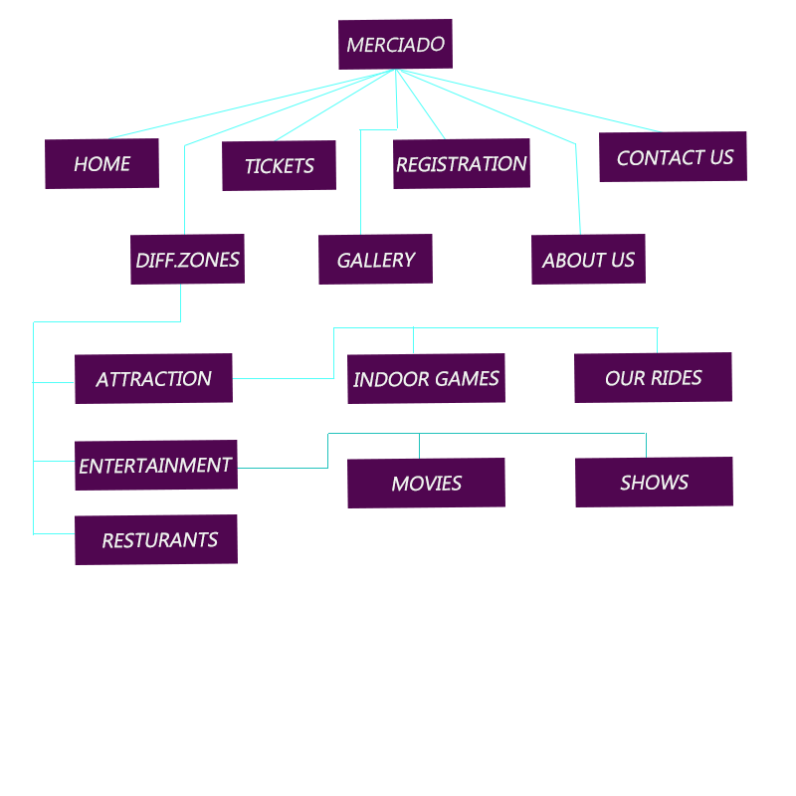

# *User Guide*

* *Homepage (landing Page)*

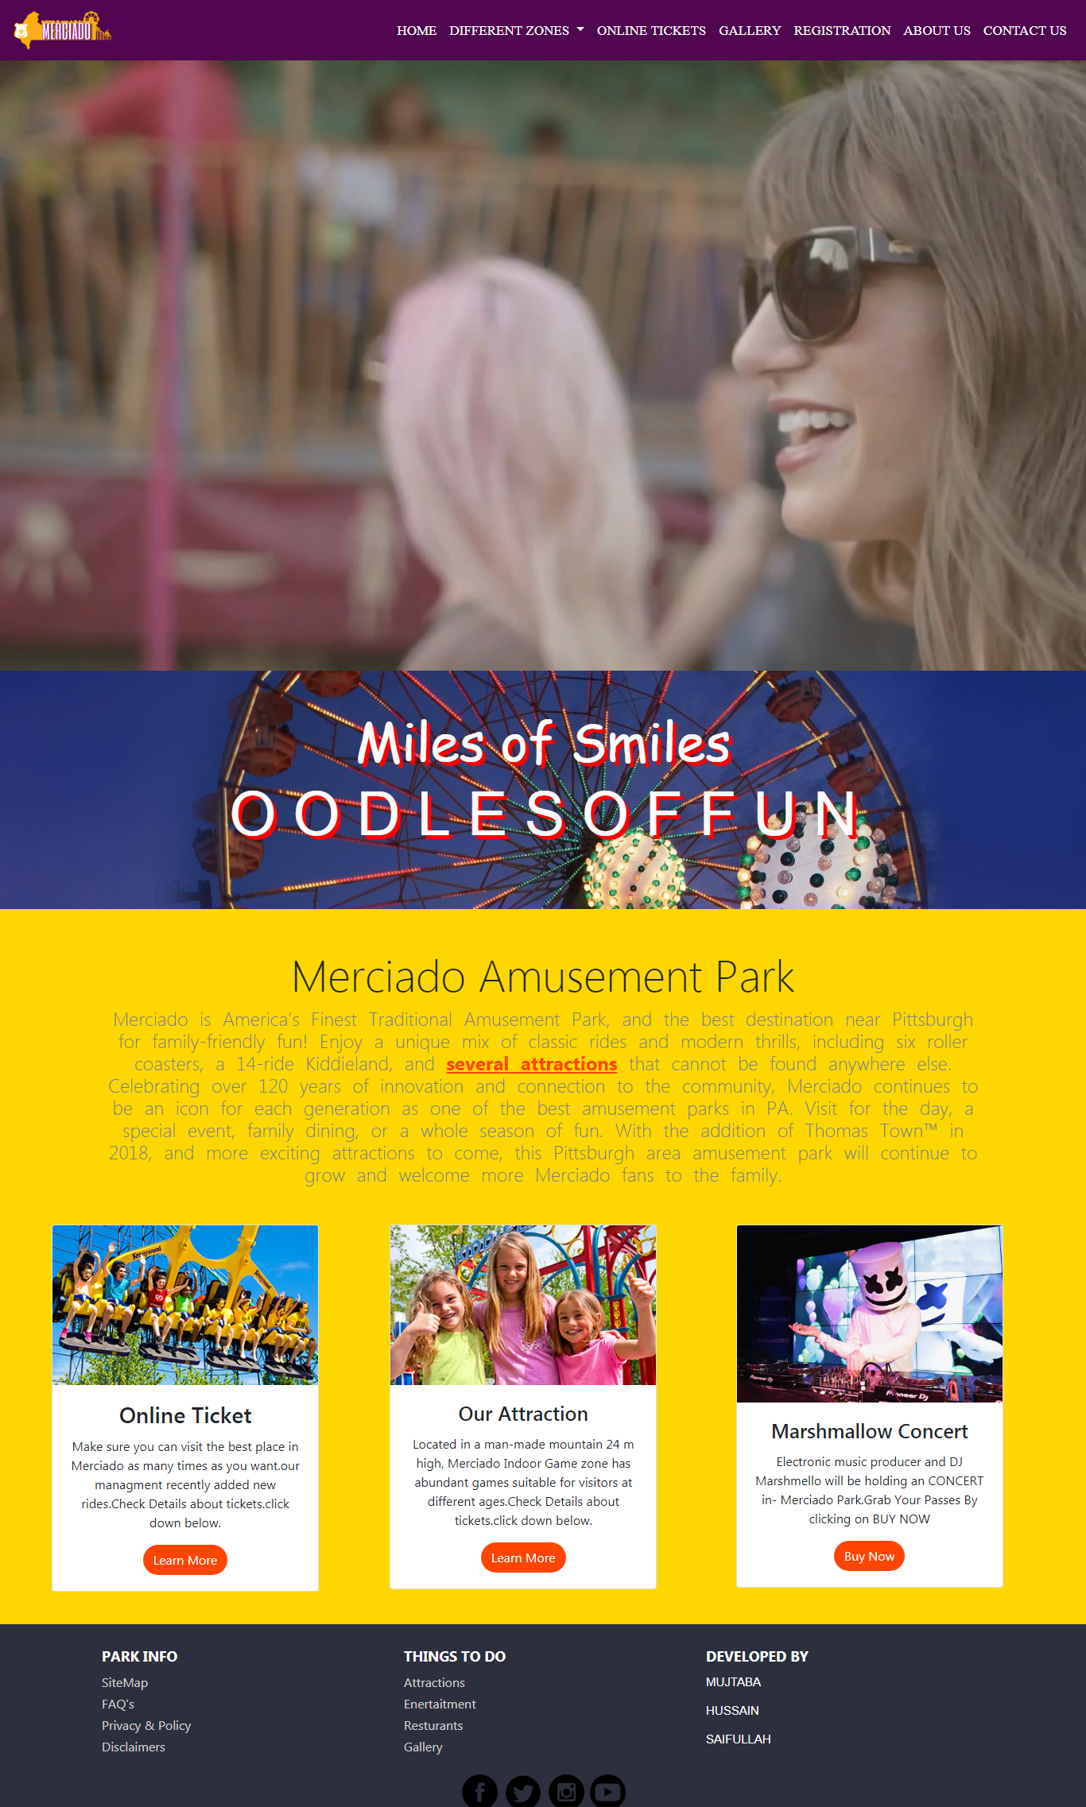

Home Page Description

*In home page if click on online ticket then you go to online ticket section*

*If click on attraction then you go to attraction section*

*Then if click on marshmello consert then you go to online ticket to buy a ticket*

* *ABOUT US*

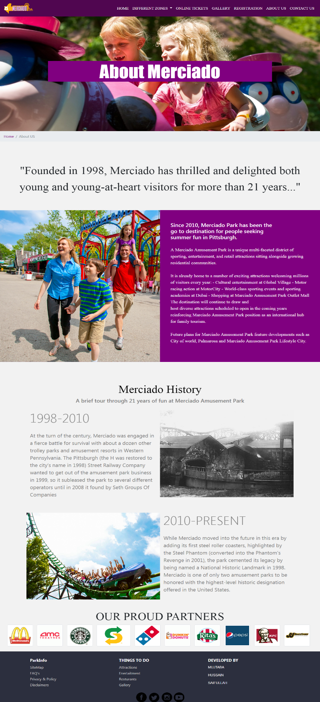

* *Contact us*

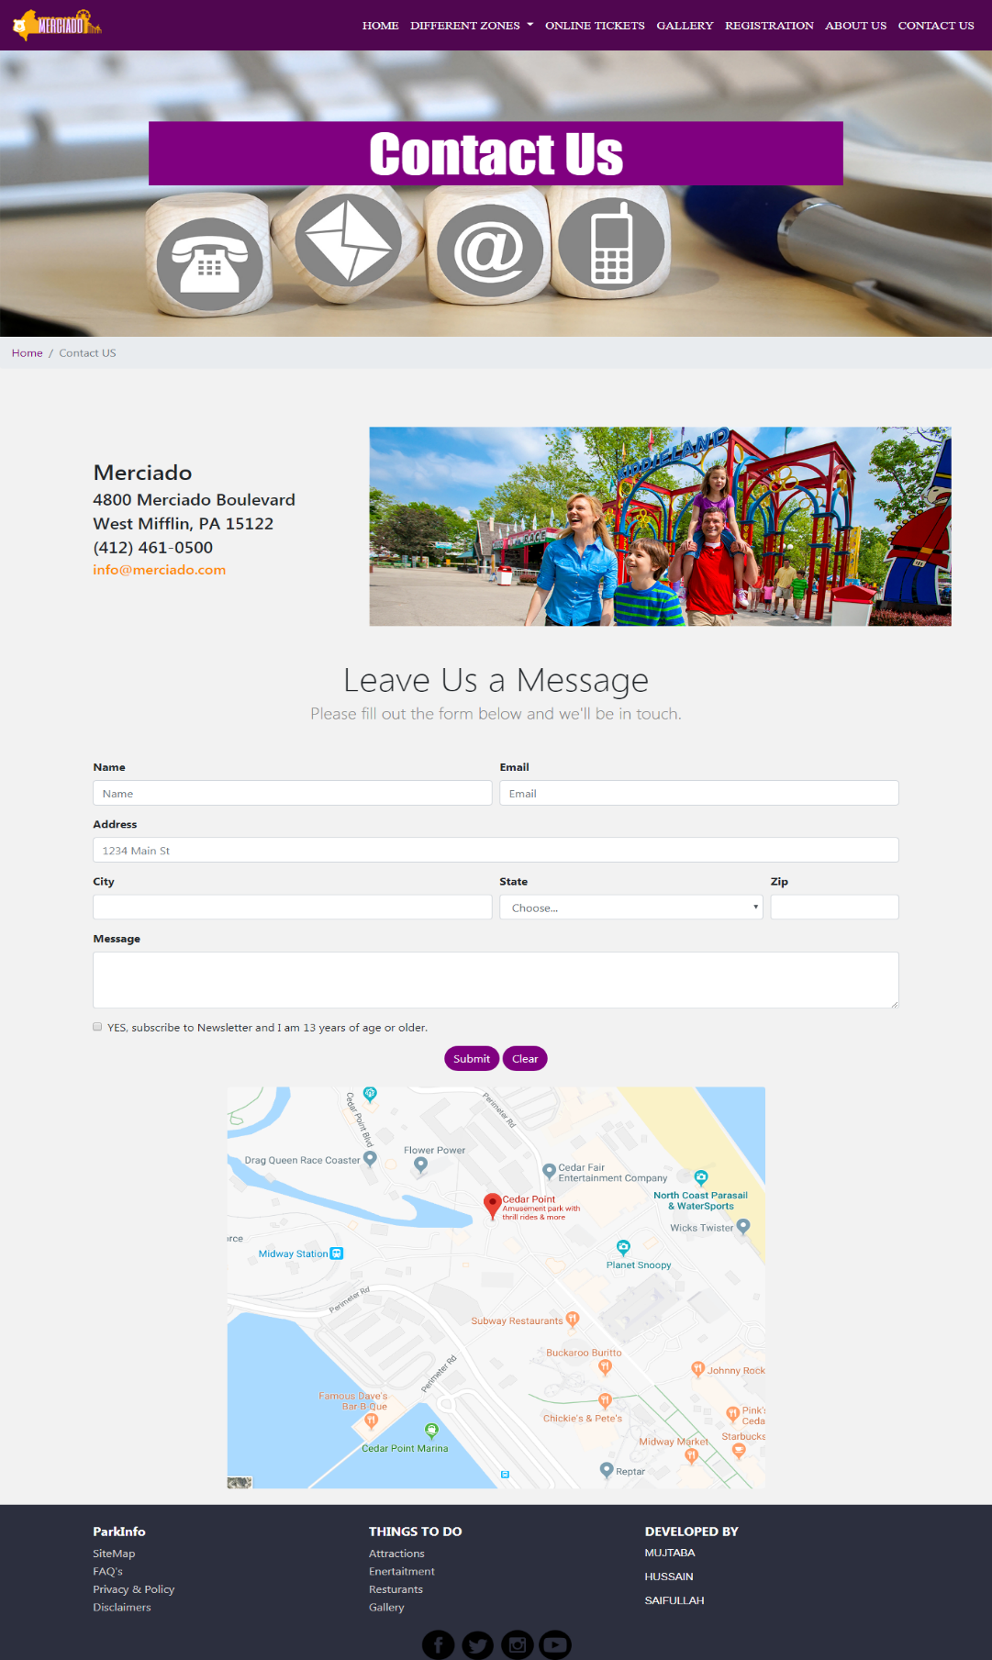

* *Online Ticket*

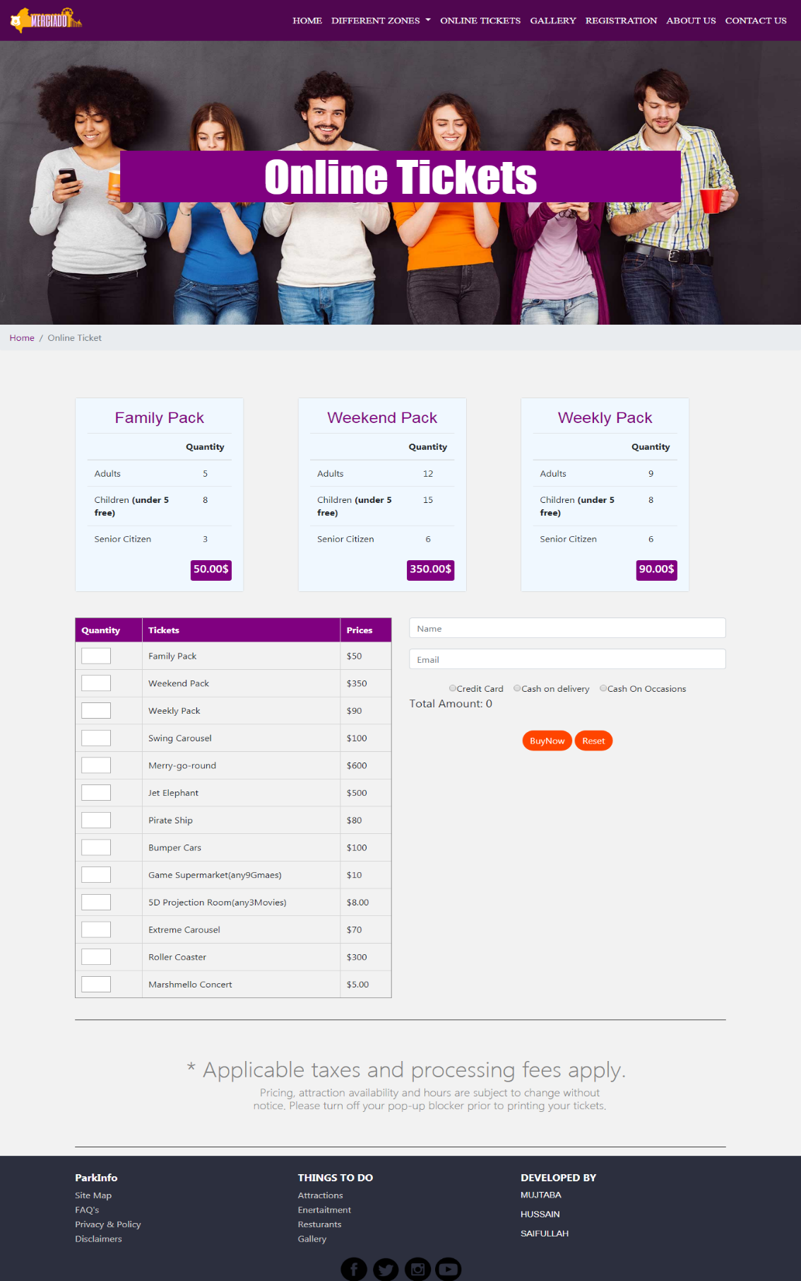

*Online Ticket description*

*Above 3 cards are align which is showing different packages. And below on left side you can choose quantity*

*Of how much tickets you want and on right above you can choose payment option and below there 2 buttons one for buy now and other is rest.*

* *Gallery*

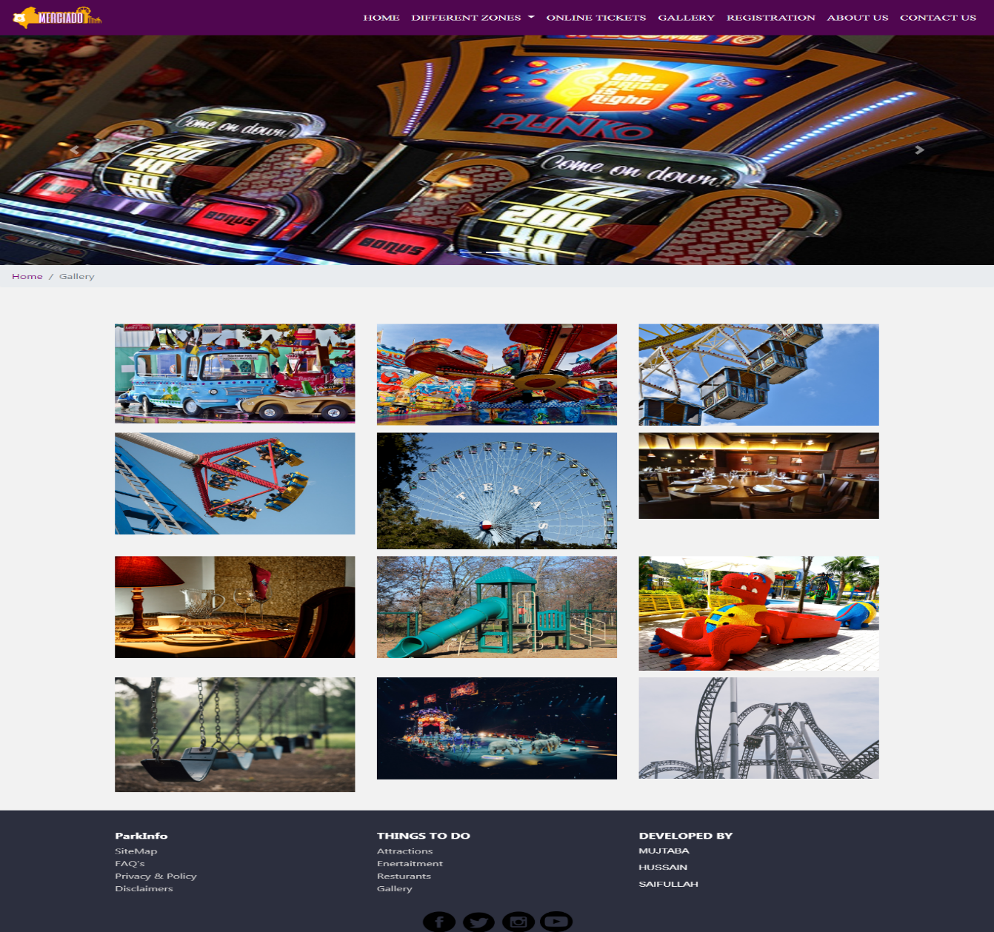

* *Registration*

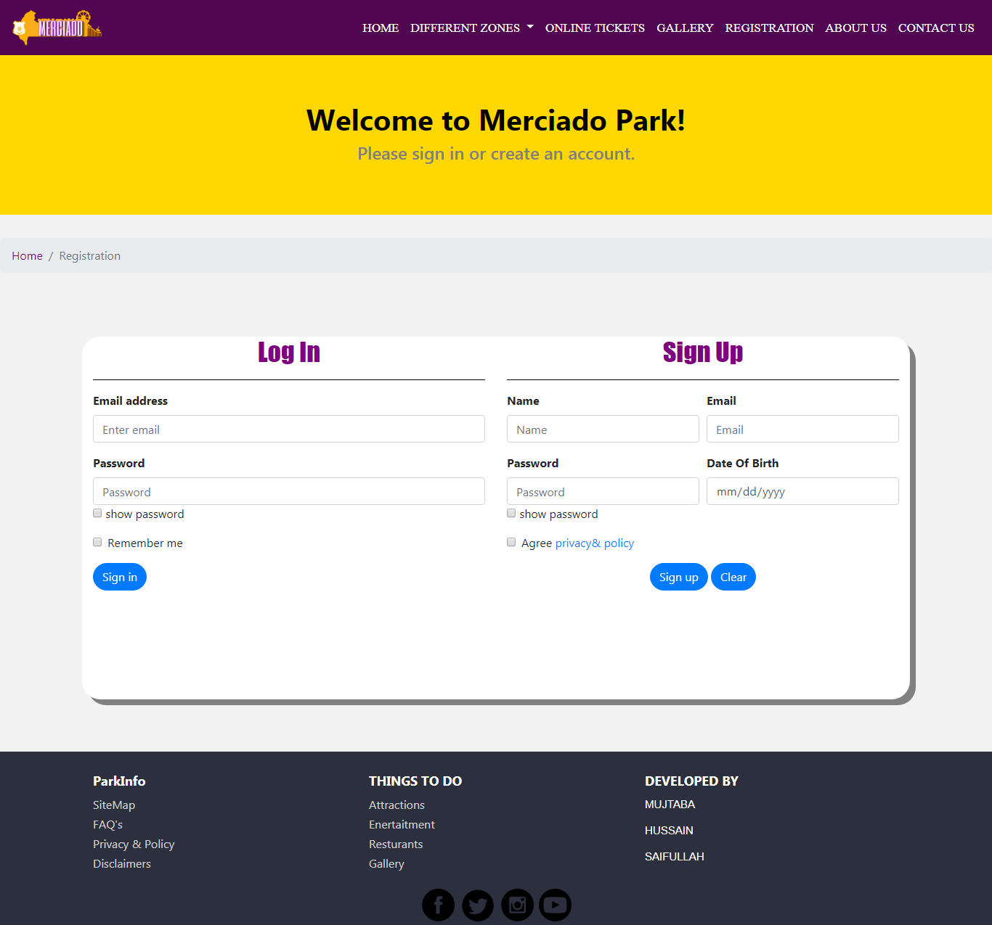

*On left Side if click on sign in it will Log in into your account And on right side there are 2 buttons are showing if click on sign up it will create an account for you if click on clear then it will clear all your data on form*

* *Resturants*

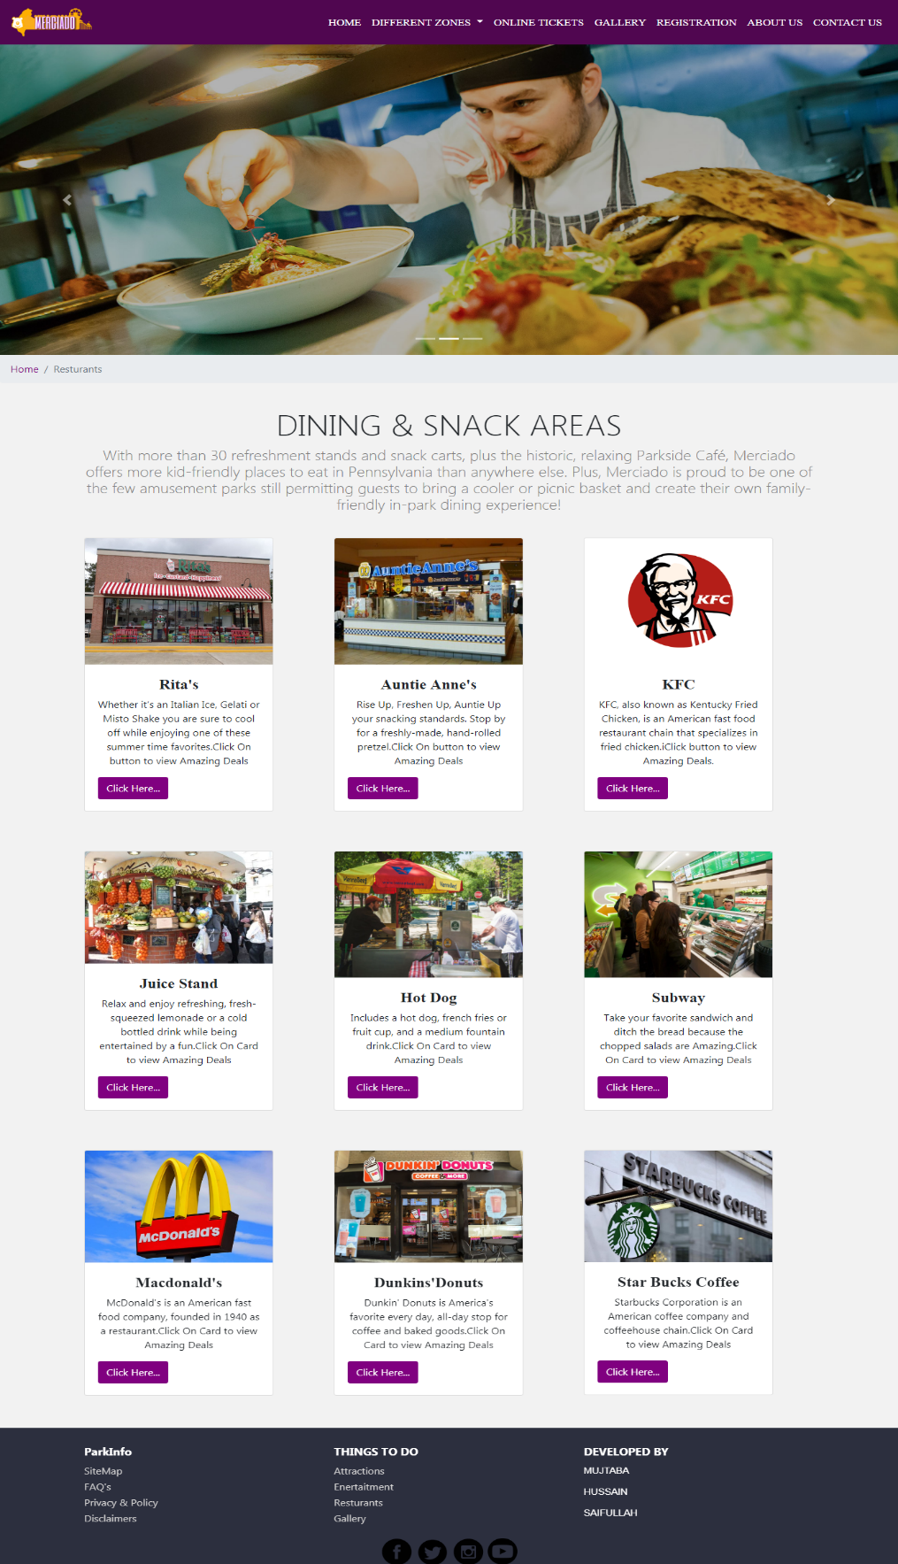

*If click on card button “click here” it will show you resturants deals.*

* *Attractions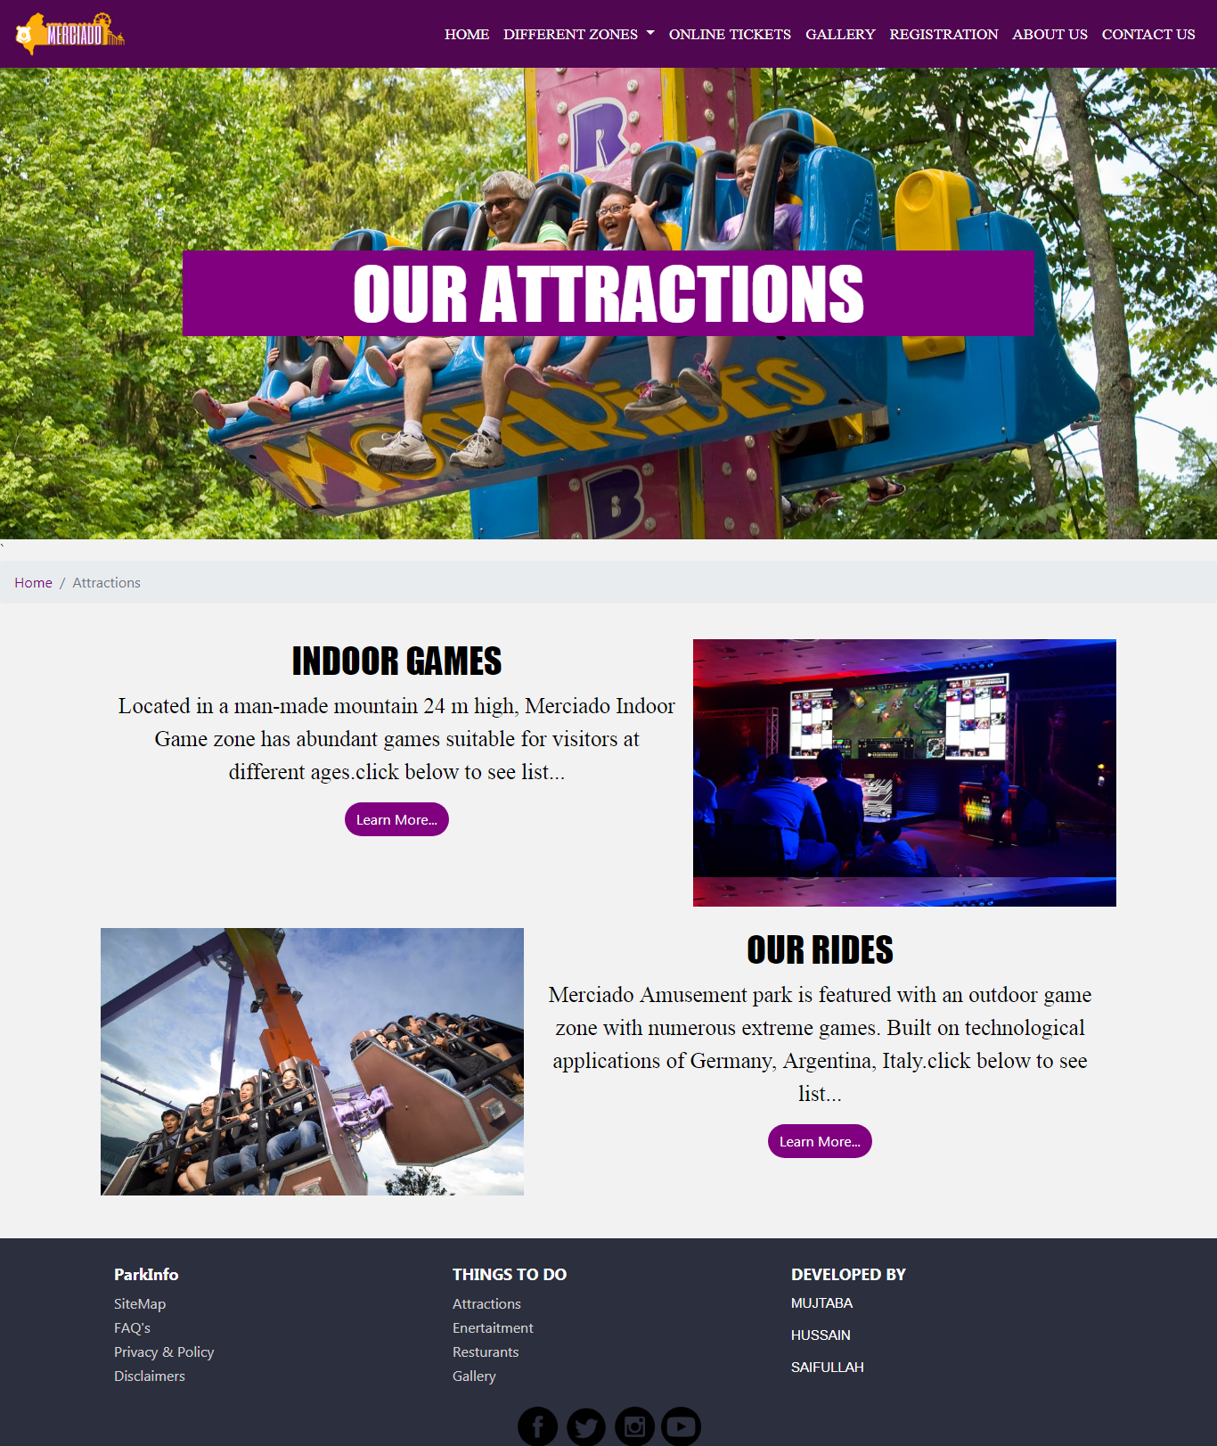*
* *Indoor games*

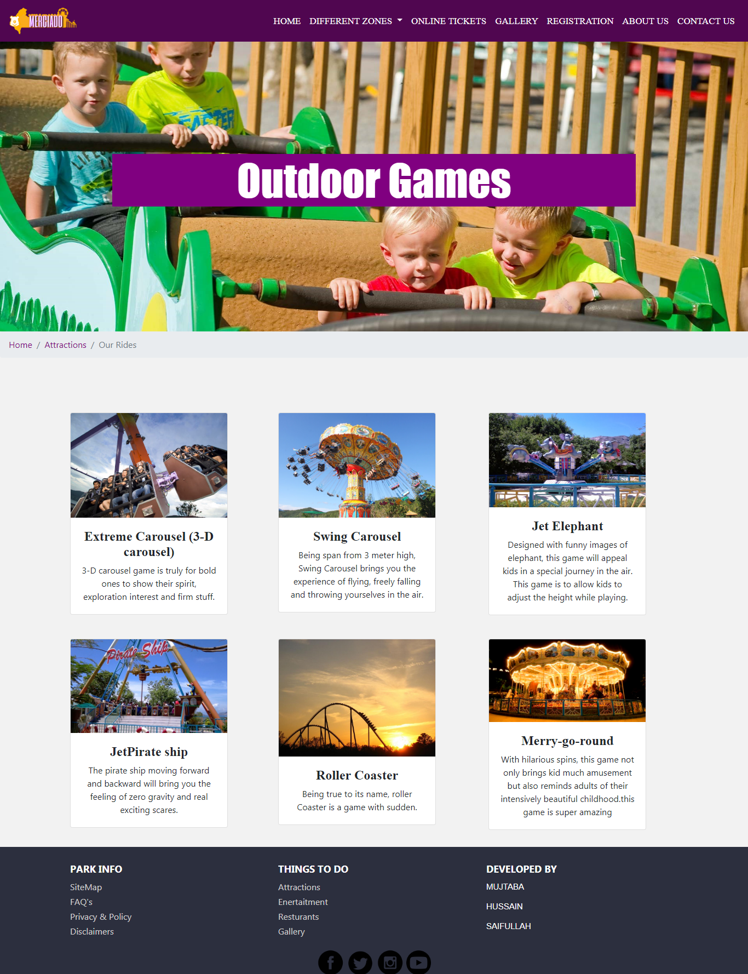

*These cards align in a row are showing details of diferent rides.*

*Rides like roller coster,jet priete ship,extreme caourusl,merry go ride, jet elepants are listed below*

* *Outdoor Games*

**

* *Entertaitment*

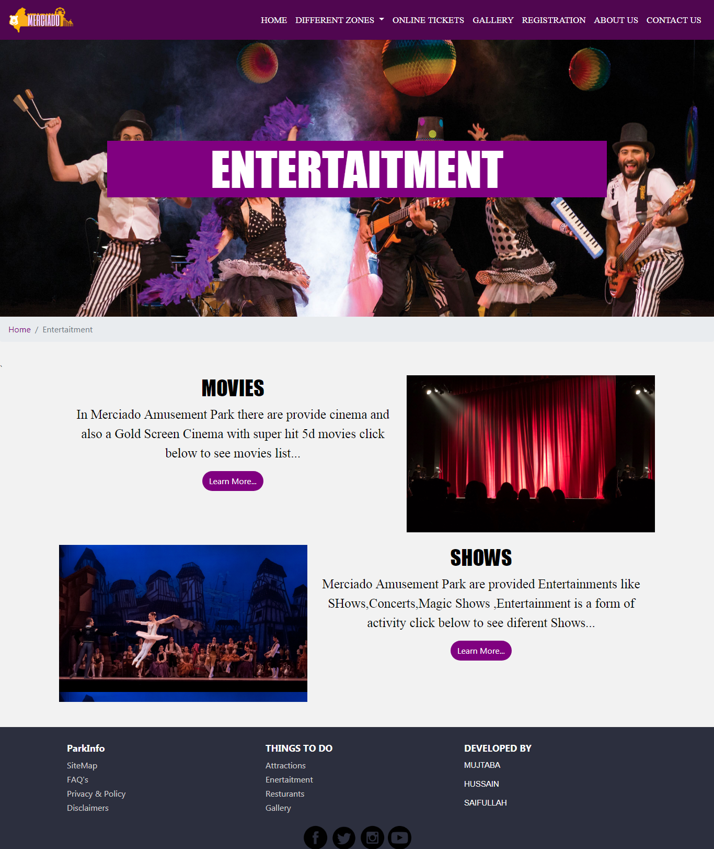

* *Movies*

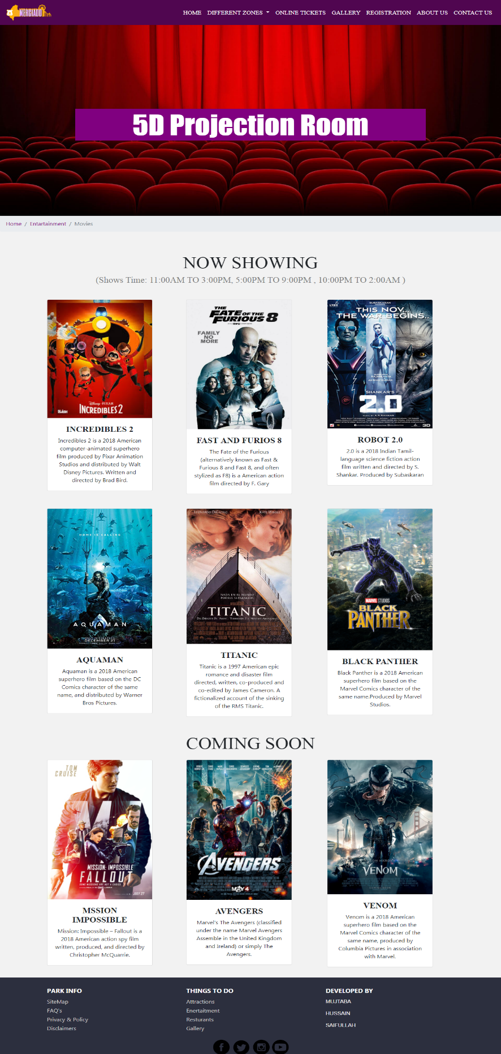

* *Shows*

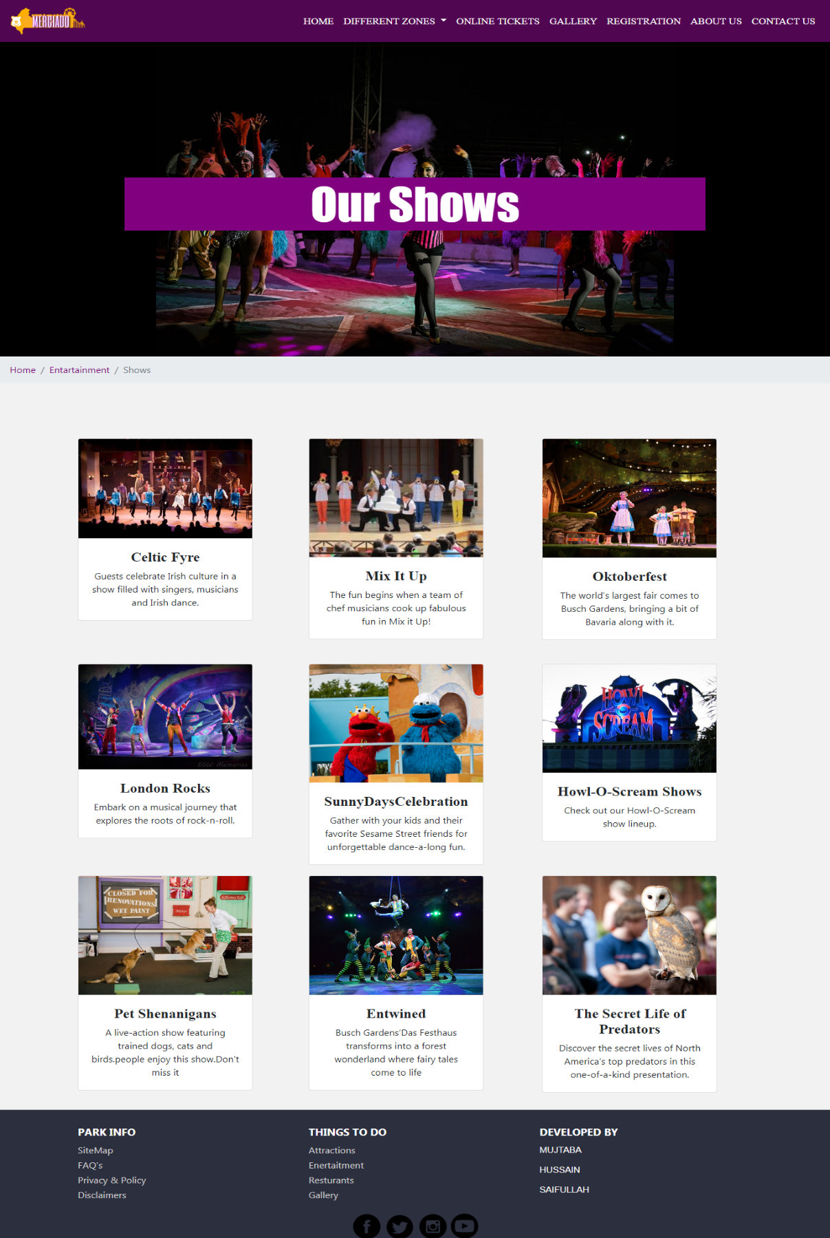

## Frequently Asked Questions:

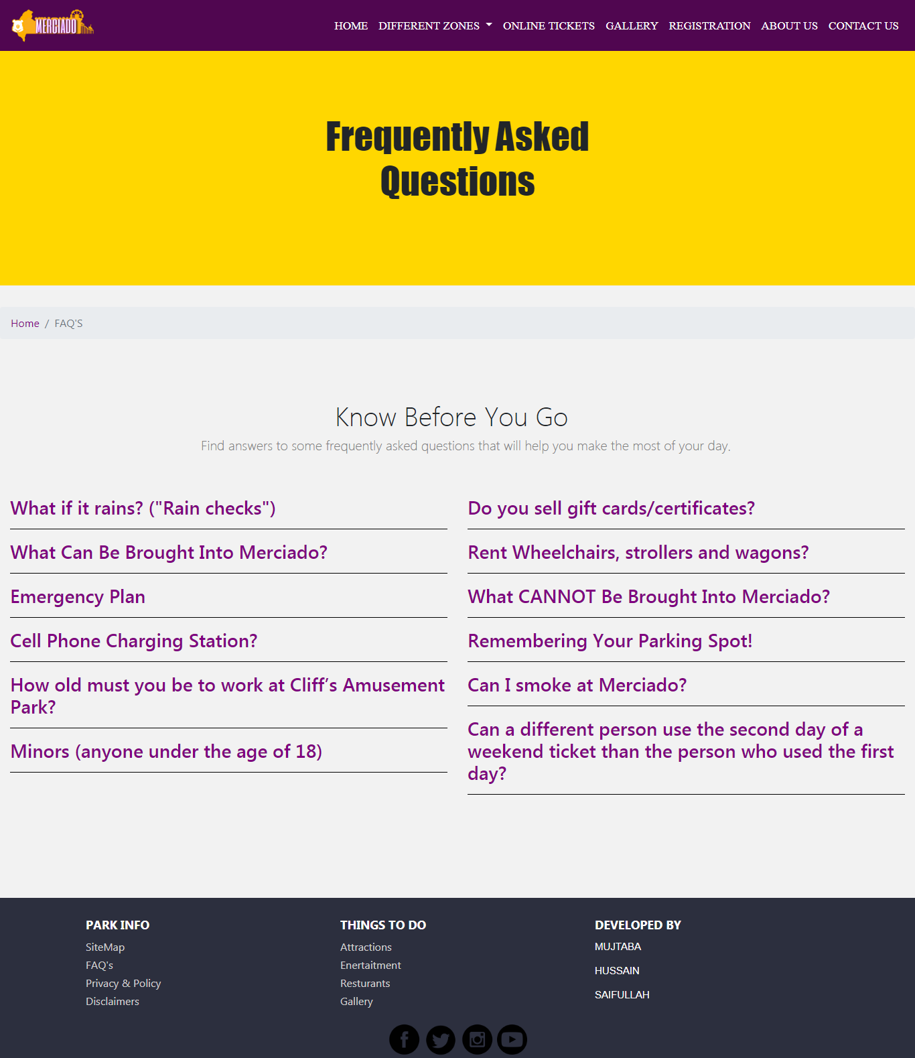

## Privacy & Policy:

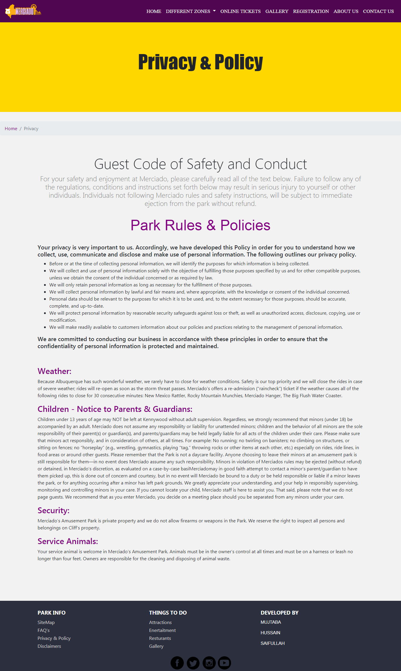

## Disclaimer:

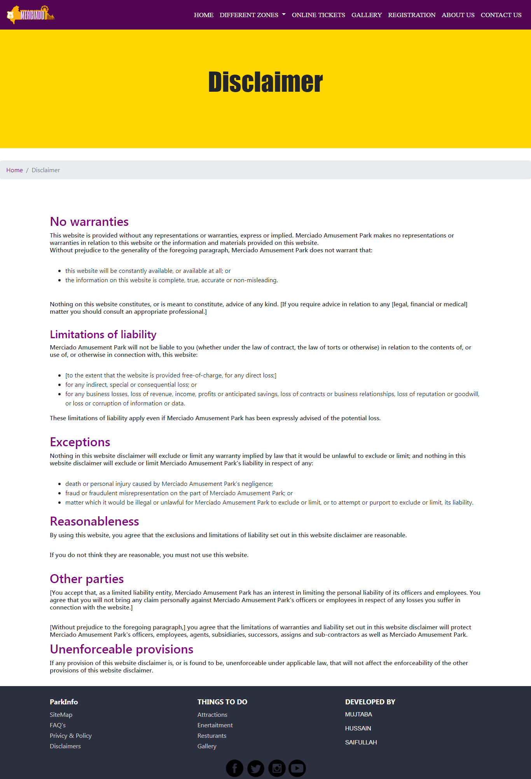

* *Site Map*

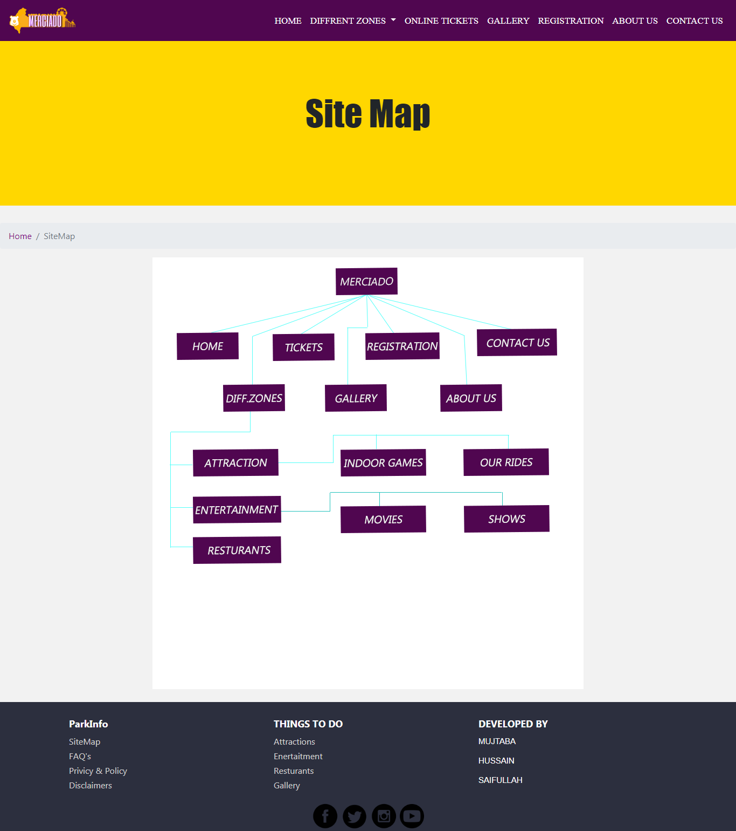

*Task Sheet*

|  |  |  |  |  |
| --- | --- | --- | --- | --- |
| Project Ref. No. | | Project Title | Date of Preparation of Activity Plan | |
| S.No. | Task | **Meerciado Amusment Park** | Actual Days | Status |
| 1 | Analysis | 1 | OK |
| 2 | Design | 5 | OK |
| 3 | Development | 3 | OK |
| 4 | Testing | 1 | OK |
| 5 | Documentation | 1 | OK |